*Worship and Class Leaders*

Kiara Jorgenson, PhD

St. Olaf Associate professor of Religion and Environmental Studies. A theologian with degrees from St. Olaf College, Denver Seminary, and Luther Seminary. Research areas include Protestant ecotheologies, vocation, ecofeminisms, agrarian studies, ecological resistance movements, childhood studies, and the theology of motherwork. She teaches about ecotheology, place-based spirituality, Biophilia, Theo-Ethics of Climate Change, and Culture of Nature.

She has multiple publications, most recently, *Ecology of Vocation: Recasting Calling in a New Planetary Era*, and edited *Ecotheology: A Christian Conversation* as well as in a variety of journals on interdisciplinary topics ranging from ecological ethics to vocation of children to indigenous influence on Christian watershed liturgies.

Kiara lives on the prairie near Nerstand’s Big Woods with her spouse, young daughters, and an assortment of furry friends. She enjoys historical fiction, gardening, running, hiking, yoga, photography, and fabric arts.

Mark Seeley, PhD

Former Extension Climatologist and Professor Emeritus of Soil, Water, and Climate for the University of MN where he managed the Weather and Climate Education Program. He has been a weekly commentator on Minnesota Public Radio’s Morning Edition and writes a weekly blog, “Minnesota Weather Talk.” He has helped Twin Cities Public Television produce award-winning documentaries and is author of the *Minnesota Weather Almanac* and co-author of *Voyageur Skies: Weather and Wilderness in Minnesota’s National Park*.

He has degrees from UC Berkely, Northern Illinois University and University of Nebraska.

He has multiple service awards such as from the MN Crop Production Retailers Association, MN Agri-Growth Council, Sigma Xi, MN/Dot, and U of MN Deans, the Siehl Prize, the University President’s award. In addition to work for the U of MN and MPR/TPT he is also a NOAA fellow and visiting scientist for the UK Meteorological office.

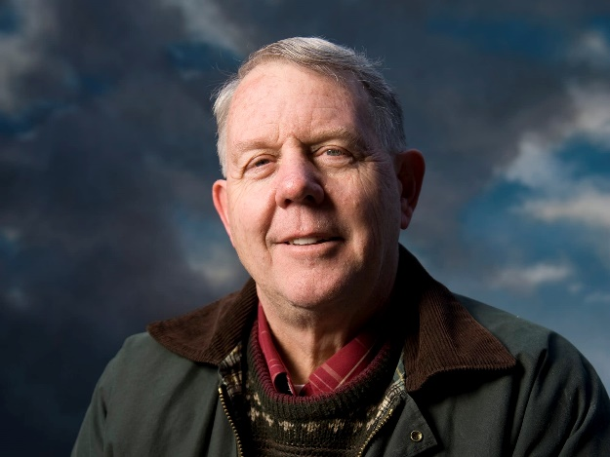

Timothy Reinhold Eberhart, PhD

Director of Center for Ecological Regeneration and Robert and Marilyn Degler McClean Associate Professor of Theology and Practice at Garrett-Evangelical Theological Seminary. He holds degrees from St. Olaf College, and PhD and Masters of Divinity from Vanderbilt University. He teaches theology and ethics, focusing on relation of Christian doctrine to environmental, economic, political, and social change. His most recent publications include *Rooted in Grounded Love: Holy Communion for the Whole Creation* and *The Economy of Salvation: Essays in Honor of M. Douglas Meeks*.

A trained Methodist elder, permaculturalist, UMC Earthkeeper and co-chair of the Oxford Institute of Methodist Theological Studies.

He lives in St. Paul with spouse Becky and has two grown children.

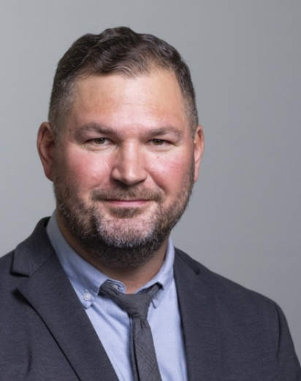

*Worship and Class Leaders*

Howard White

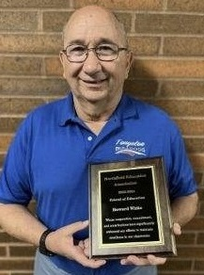A retired ELCA Lutheran pastor.  He has served eight different congregations and also worked for 15 years as a capital fundraiser for churches.  Northfield UMC was one of his clients.  He has lived in Northfield for 33 years with his wife Janet, who served Northfield UMC as associate pastor some 20 years ago. Howard has been active in Citizens’ Climate Lobby since 2016 and served as the Northfield chapter co-leader (with Janet Petri) since 2018.  He is also CCL’s liaison to the office of Rep. Angie Craig.

Mary Lynn Oglesbee

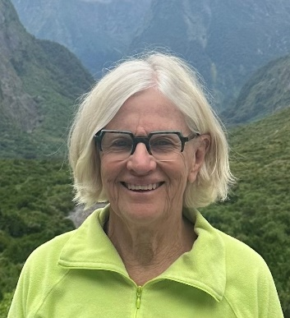A trained and experienced facilitator/retreat leader for the Center for Courage and Renewal (based on Parker Palmer’s writings.) She has served on the board of Women in Northfield Giving Support (WINGS) and Northfield Shares. She is a retired clinic administrator for Fairview Health and grandmother to Cormac and Ada.

Series Schedule

April 27

9:30 am – Worship guest preacher: Dr. Kiara Jorgenson. Sermon: Hope Through Tears

10:30 am – Class: Our Current Climate Situation with guest teacher Dr. Mark Seeley.

May 4

9:30 am – Worship guest preacher: Dr. Timothy Eberhart. Sermon: Called to be Creatures

10:30 am – Class: God in All Things: Recovering our Spiritual Ties to the Land with Dr. Eberhart.

May 11

9:30 am – Worship, Pastor Donna Dempewolf. Sermon: Listening for a Voice

10:30 am – Class: Courage and Renewal guest facilitator Mary Lynn Oglesbee.

May 18

9:30 am – Worship guest preacher: Rev. Howard White. Sermon: A Path and Plan of Resolution Love

Climate Witness: Tim Goodwin, educator, author, musician.

10:30 am – Class: What Then Shall We Do (John 3:10)? Panel Discussion facilitated by Clay Oglesbee with panelists: Alan Anderson, Richard DeBeau, Howard White and others.



Worship. Compassion.

Devotion. Justice.



Earthrise. Photo taken aboard Apollo 8 by Bill Anders

Caring For Creation:

“What Then Should We Do?” (John 3:10)

A four-week worship and teaching series April 27 – May 20 open to the entire community to consider together current understanding of climate crisis and what it means for all in these times

Northfield United Methodist Church

1401 Maple Street